A comprehensive guide for setting up and using Playwright with TypeScript on a Linux system.
This guide includes installation, setup, writing tests, and running the tests in a step-by-step breakdown.

Official Documentation: https://playwright.dev/docs/intro
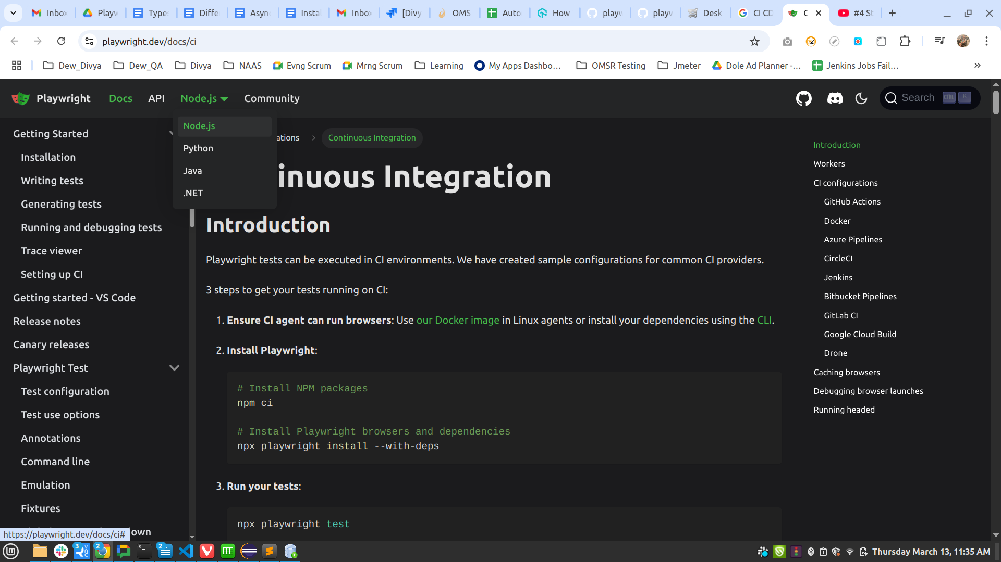

1. Install Node.js and NPM
Playwright is a Node.js library, so you need to have Node.js installed on your Linux machine. If you don’t have it installed yet, follow these steps.

Install Node.js and NPM
- Ubuntu/Debian-based systems:
bash
CopyEdit
sudo apt update
sudo apt install nodejs npm
- CentOS/Fedora/RHEL-based systems:
bash
CopyEdit
sudo dnf install nodejs npm
You can check if Node.js and npm are successfully installed using:
bash
CopyEdit
node -v
npm -v

2. Create a Project Folder
Create a directory for your Playwright project, then navigate into it.
bash
CopyEdit
mkdir playwright-typescript
cd playwright-typescript

3. Initialize a Node.js Project
Next, initialize a new Node.js project by running:
bash
CopyEdit
npm init -y
This will create a package.json file.

4. Install Playwright and TypeScript
Now, you need to install Playwright, TypeScript, and some additional TypeScript dependencies.
bash
CopyEdit
npm install playwright
npm install typescript @types/node ts-node --save-dev

5. Set Up TypeScript Configuration
Create a tsconfig.json file to configure TypeScript. You can generate one using the following command:
bash
CopyEdit
npx tsc --init
Modify the tsconfig.json to make sure it works with Playwright by adding or updating the following options:
json
CopyEdit
{
"compilerOptions": {
"target": "ESNext",
"module": "CommonJS",
"moduleResolution": "Node",
"esModuleInterop": true,
"skipLibCheck": true,
"strict": true,
"forceConsistentCasingInFileNames": true
}
}

6. Write Your First Playwright Test in TypeScript
Now, you can start writing your first Playwright test. Create a new file, for example test.spec.ts in your project directory.
ts
CopyEdit
import { chromium } from 'playwright';

describe('Playwright Test', () => {
it('should open a page and check the title', async () => {
const browser = await chromium.launch(); // Launch browser
const page = await browser.newPage(); // Create new page

await page.goto('https://example.com'); // Go to example.com
const title = await page.title(); // Get the title of the page

console.log(title); // Print title to the console
expect(title).toBe('Example Domain'); // Assert title
await browser.close(); // Close the browser
});
});
In this example, we are:
- Launching the Chromium browser.
- Opening a new page.
- Navigating to "https://example.com".
- Verifying the page title.
- Closing the browser after the test.

7. Add Playwright Test Runner (Optional)
Playwright has its own testing library that integrates well with TypeScript. If you want to use Playwright’s built-in test runner, install it via:
bash
CopyEdit
npm install @playwright/test
Then update your test file to use Playwright’s test runner. Create a new file test.spec.ts as follows:
ts
CopyEdit
import { test, expect } from '@playwright/test';

test('should open a page and check the title', async ({ page }) => {
await page.goto('https://example.com');
const title = await page.title();
expect(title).toBe('Example Domain');
});

8. Running the Tests
To run your Playwright tests with TypeScript, you can use either of the following methods:
- Using ts-node:
If you want to run TypeScript directly with ts-node, you can run:
bash
CopyEdit
npx ts-node test.spec.ts
- Using Playwright Test Runner:
If you’re using Playwright's built-in test runner, you can run the tests with:
bash
CopyEdit
npx playwright test

9. Configure Playwright for Browser Downloads
The Playwright package downloads necessary browser binaries (Chromium, Firefox, WebKit) during installation. If you want to explicitly download them, you can use:
bash
CopyEdit
npx playwright install

10. Example of Running Tests with Multiple Browsers
To test on multiple browsers, you can use Playwright’s built-in browser support. Here's an example:
ts
CopyEdit
import { test, expect } from '@playwright/test';

test('should check title on different browsers', async ({ page, browserName }) => {
await page.goto('https://example.com');
const title = await page.title();
expect(title).toBe('Example Domain');
});
Playwright will automatically run the test on all supported browsers (Chromium, Firefox, WebKit).

11. Playwright Configuration
You can configure your tests by creating a playwright.config.ts file. Here’s a basic example:
ts
CopyEdit
import { defineConfig, devices } from '@playwright/test';

export default defineConfig({
use: {
browserName: 'chromium', // Set default browser
headless: false, // Run tests in headless mode (set to false to see the browser UI)
screenshot: 'only-on-failure',
video: 'retain-on-failure',
},
projects: [
{
name: 'Desktop Chrome',
use: { ...devices['Desktop Chrome'] }, // Test on Desktop Chrome
},
{
name: 'Mobile Safari',
use: { ...devices['iPhone 12'] }, // Test on Mobile Safari
},
],
});

12. Advanced Topics
- Handling Elements and Interactions: Playwright provides a wide variety of methods for interacting with elements:
  - page.click(selector)
  - page.fill(selector, text)
  - page.selectOption(selector, option)
  - page.hover(selector)
- Waits and Timeouts: Playwright automatically waits for elements to be ready before interacting with them, but you can also use explicit waits:
  - await page.waitForSelector(selector)
  - await page.waitForTimeout(milliseconds)
- Screenshots and Videos: Playwright can automatically take screenshots or videos of test runs for debugging:
ts
CopyEdit
await page.screenshot({ path: 'screenshot.png' });
await page.video().saveAs('video.mp4');
- Network Interception: You can mock API requests and intercept network traffic with Playwright, which is useful for testing how your application behaves with different network conditions.

13. Conclusion
This guide should help you get started with using Playwright and TypeScript for testing on Linux. Playwright provides a powerful and flexible toolset for browser automation, and the combination with TypeScript gives you type safety and editor support for writing tests.

